NEW YORK/NEW JERSEY
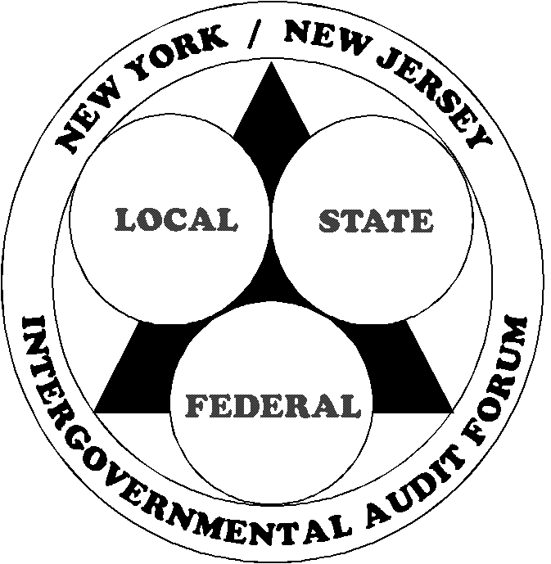
INTERGOVERNMENTAL AUDIT FORUM
c/o NYS Office of the State Comptroller, Division of State Government Accountability
123 William Street, 21st Floor
New York, NY 10038
(212) 417-5200
FAX: (212) 417-5176

Executive Committee  Forum Chair  Kenrick Sifontes  NYS Comptroller’s Office  (212) 417-5439  Vice Chair  Gordon Taylor, Esq.  City University of NY  (646) 746-4283  Executive Director  Frank Patone, CPA  NYS Comptroller’s Office  (212) 417-5191  Immediate Past Forum Chair  William Challice, CIA, CFE  NJS Comptroller’s Office  (609) 984-2888  Immediate Past Exec. Dir.  Stephen Eells  NJ State Auditor  ( 609) 292-3700  Committee Chairs  Membership  Robert Murray  MTA I. G.’s Office  (212) 878-0050  Program & Training  Ruth-Ami Klein  U.S. Dept. of Labor-OIG  ( 646) 264-3510  Finance  Anne Vidunas-Gladwell, CPA  NJS Comptroller’s Office  (609) 984-2888  GAO Liaison  Mary Mohiyuddin  (202) 512-3087  Members at Large  James P. Edert  U.S. Dept. of HHS-OIG  (212) 264-4620  Randy Nelson  Ernst and Young  (732) 516-4340  Alyce Frazier  U.S. Dept. Of Education-OIG  (646)428-3871 | To: Forum Members and Associates  From: Frank Patone, Executive Director  Date: 2014  Subj: 2014 Spring Conference  You are cordially invited to attend the New York/New Jersey Intergovernmental Audit Forum’s Spring Conference for 2014.  Our one day conference will be held on Thursday, May 29, 2014, at the Baruch College “Newman Conference Center” located at 151 East 25th Street between Third and Lexington Avenues.  This year’s conference will address several topical issues that you should find interesting, informative and useful in your assigned responsibilities. The conference agenda and registration form are attached to this email. I plan on sending out the instructor bios and detailed course descriptions next week.  The low-cost conference fee is $125 per attendee and will cover your 7 CPEs, continental breakfast, a hot lunch and both AM and PM breaks. Please make your check or agency voucher payable to “NY/NJ Intergovernmental Audit Forum,” and mail with your completed registration form to our Treasurer, (Anne Vidunas-Gladwell, Deputy Director, NJS Office of the State Comptroller, P.O. Box 024, Trenton, NJ 08625-0024). If you have any questions regarding payment, Anne can be reached at (609) 984-2888.  Your registration form must be received by c.o.b. Friday, May 23, 2014. We understand that payments from major agencies may take a bit longer to process. Cash or credit cards will not be accepted.  For questions regarding the Conference, please call me, Forum Chair Ken Sifontes or Vice Chair Gordon Taylor at the numbers listed in the left hand column. You can visit our website at www.auditforum.org.

